**Ye,Zhengkun**

**Project 3**

[**zhengkunye@gmail.com**](mailto:zhengkunye@gmail.com)

**02/18/2014**

**package** project3;

**import** java.util.Scanner;

**public** **class** ConvertToUpper {

// Written by Ye,Zhengkun

Scanner stdin = **new** Scanner(System.*in*);

**public** **static** **void** main(String[] args) {

System.*out*.println("type a letter：");

String smallletter = (**new** Scanner(System.*in*)).next();

**char** letter = smallletter.charAt(0);

**char** capitalletter = 'a';

**if** (letter >= 97 && letter <= 122) {

capitalletter = (**char**) (letter - 32);

System.*out*.println("the capital letter is：" + capitalletter);

}

**else**

System.*out*.println("What was entered was not a lowercase letter.");

}

}

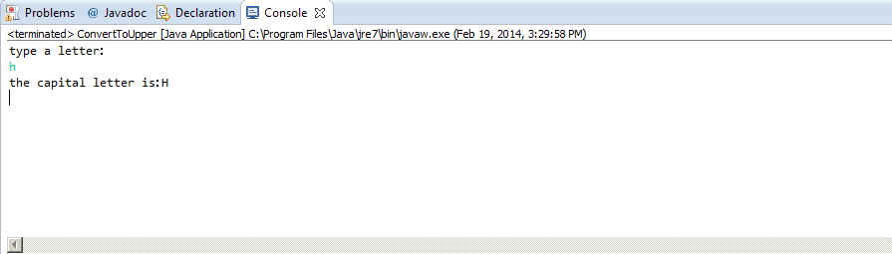

**package** project3;

**import** java.util.Scanner;

**public** **class** Circle {

**public** **static** **void** main(String[] args) {

**double** a,b,c;

Scanner input = **new** Scanner(System.*in*);

System.*out*.println("Enter the x value");

a = input.nextDouble();

System.*out*.println ("Enter the y value");

b = input.nextDouble();

c = Math.*sqrt*(Math.*pow*(a,2) + Math.*pow*(b,2));

**if** (c <= 10) {

System.*out*.println ("The point (" + a + " , "+ b +") is in the circle!");}

**else** { System.*out*.println ("The point " + c +" is not in the circle");

}

}

}

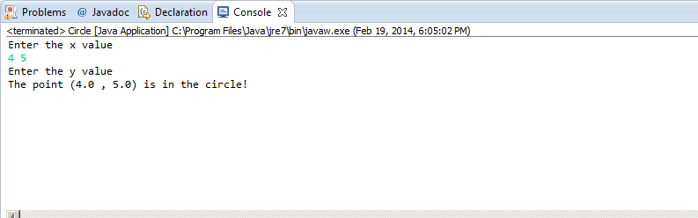

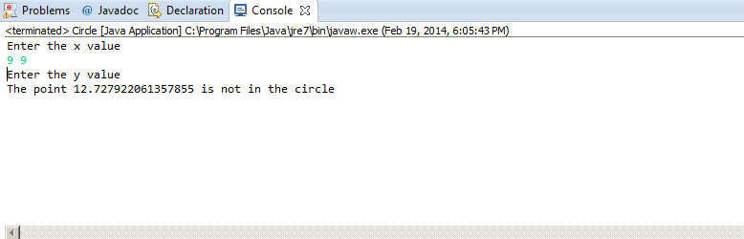

**import** java.util.Scanner;

**public** **class** ThreeGuesses { //Written by Ye,Zhengkun

**public** **static** **void** main(String[] args) {

Scanner sc = **new** Scanner(System.*in*);

System.*out*.println("Welcome to People's Bank.");

System.*out*.println("Please enter your secret code:");

**int** code1= sc.nextInt();

**if**(code1 == 51){

System.*out*.println("Fine, go ahead.");

}

**else**

System.*out*.println("Sorry, that is not it. Try again:");

**int** code2= sc.nextInt();

**if**(code2 == 51){

System.*out*.println("Fine, go ahead.");

}

**else**

System.*out*.println("Sorry, last chance. Try again:");

**int** code3= sc.nextInt();

**if**(code3 == 51){

System.*out*.println("Fine, go ahead.");

}

**else**

System.*out*.println("Sorry, you have failed 3 times. Please try again later.");

}

}

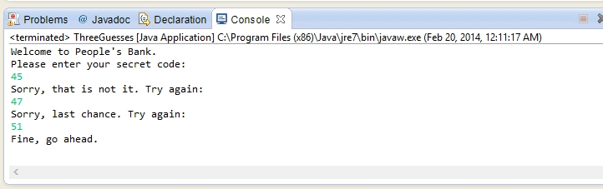

**import** java.util.Scanner;

**public** **class** Taxes {// Written by Ye,Zhengkun

**public** **static** **void** main(String[]args){

Scanner sc = **new** Scanner(System.*in*);

System.*out*.println("Enter your net taxable income: ");

**double** income= sc.nextDouble();

**double** temp = 0;

**if** (income <= 8700) {

System.*out*.println("Your 2012 tax is $" + 0.10*income);

}

**else** **if**(income > 8700 && income <= 35350){

temp = 0.10*8700+0.15*(income-8700);

System.*out*.println("Your 2012 tax is $" + temp);

}

**else** **if**(income > 35350 && income <= 85650){

temp = 0.10*8700+0.15*(35350-8700)+0.25*(income-35350);

System.*out*.println("Your 2012 tax is $" + temp);

}

**else** **if**(income > 85650 && income <= 178650){

temp = 0.10*8700+0.15*(35350-8700)+0.25*(85650-35350)+0.28*(income-85650);

System.*out*.println("Your 2012 tax is $" + temp);

}

**else** **if**(income > 178650 && income <= 388350){

temp = 0.10*8700+0.15*(35350-8700)+0.25*(85650-35350)+0.28*(178650-85650)+0.33*(income-178650);

System.*out*.println("Your 2012 tax is $" + temp);

}

**else** **if**(income > 388350){

temp = 0.10*8700+0.15*(35350-8700)+0.25*(85650-35350)+0.28*(178650-85650)+0.33*(388350-178650)+0.35*(income-388350);

System.*out*.println("Your 2012 tax is $" + temp);

}

}}

